APPENDIX XX
REPORT OF THE ONE-DAY SEMINAR
ORGANISED BY PONDICHERRY STATE CENTRE, PUDUCHERRY
FOR PUBLICATION IN WEBSITE
Pondicherry State Centre, Puducherry
Name of Centre/Overseas Chapter:
Title of Activity: |  | One-Day Seminar On Green Energy And Sustainable Development
Activity under Divisional Board |  |  |  | Interdisciplinary Coordination Committee (ICC), IEI
Date: | 11.08.2025 |  | Venue: |  | Seminar Hall, Puducherry Technological University

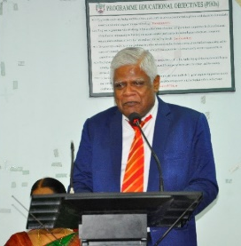  Welcome Address by  Dr.S. Mohan, Vice- Chanceller, PTU,  Puducherry  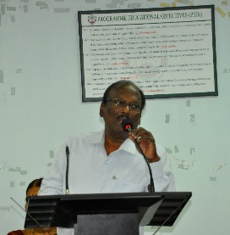  Felicitation & Chairman’s Address by  Dr. S. Thirougnaname, Chairman, IEI, PSC  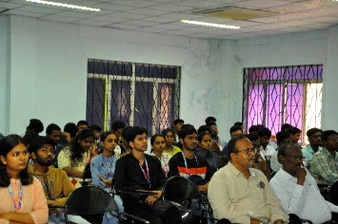  Participated Students and Teachers, Puducherry  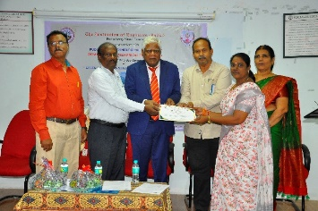  Certificated issued to the Participants  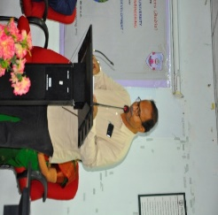  Vote of thanks to Er. K. Soundararajan, Hon. Secretary, IEIPSC | 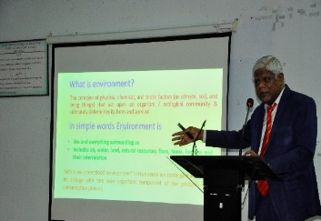  Dr.S. Mohan, Vice- Chanceller, PTU, Puducherry, State Centre delivered a lecture on topic sustainable development policy  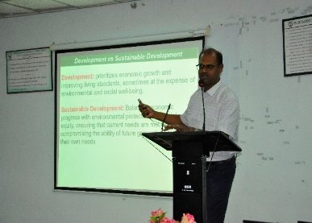  Dr. K. Suresh Babu, Professor, Department of Nano Science and Engineering, Pondicherry University Nano Materials for Sustainable Development  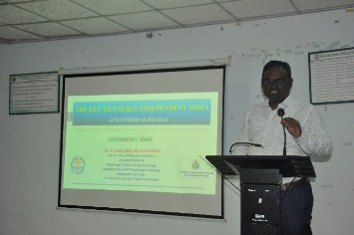  Dr. K. Karthik Selva Kumar, Assistant Professor, Centre for Green Energy Technology, Pondicherry University discussed the importance of green energy / Renewable Energy  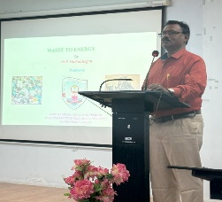  Dr. P. Mathiazhagan, Professor, Department of Mechanical Engineering, Puducherry Technological University, covered methods of converting waste into energy
Photo of Inaugural Session with banner of IEI | Photo of Technical Session

INVITATION

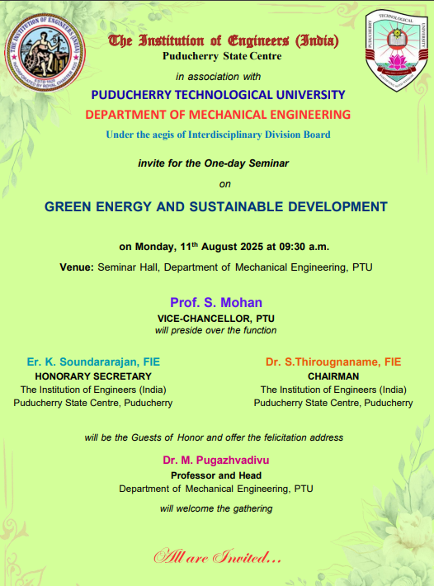

Report for One-Day Seminar

Brief Program Information:

A one-day seminar was organized by the IE (I) Puducherry State Centre, Puducherry, under the aegis of the Interdisciplinary Coordination Committee (ICC) on 11.08.2025 at the Seminar Hall of the Mechanical Engineering Department, Puducherry Technological University, Puducherry. The seminar aimed to create awareness about green energy, a cleaner environment, and cost-effective solutions in the field of green energy and sustainable development. The inaugural function was followed by four expert lectures. The seminar was planned in such a way that the forenoon session included two expert lectures, and the afternoon session included two more.
The seminar commenced at 9:30 a.m. with a brief invocation and the lighting of the kuthuvilakku, followed by the welcome address by Dr. M. Pugazhvadivu, HOD/Mechanical Engineering, who outlined the seminar objectives and the significance of green energy and sustainable development. This was followed by felicitation addresses by Dr. S. Thirougnaname, Chairman, IE (I) Puducherry State Centre and Er. K. Soundararajan, Honorary Secretary, IE (I) Puducherry State Centre. In their felicitation addresses, they emphasized the impact of green energy policies and recent developments in sustainable energy sources, highlighting the importance of conducting such seminars.
The presidential address was delivered by Dr. S. Mohan, Vice-Chancellor, Puducherry Technological University, who shared his expertise on sustainable development goals and the importance of the economic aspects of sustainable development.
In the forenoon session, the first expert lecture was delivered by Dr. S. Mohan, Vice-Chancellor, Puducherry Technological University. His talk was very informative, helping participants understand sustainable development goals in India and other countries.
The second lecture of the forenoon session was delivered by Dr. K. Suresh Babu, Professor, Department of Nano Science and Engineering, Pondicherry University. He shared his experience in the field of nanomaterials used in fuel cells and discussed ways to achieve higher efficiency in fuel cells.
The first afternoon lecture was presented by Dr. K. Karthik Selva Kumar, Assistant Professor, Centre for Green Energy Technology, Pondicherry University. He discussed the importance of green energy and focused on improving solar PV efficiency through material modification.
The final session was addressed by Dr. P. Mathiazhagan, Professor, Department of Mechanical Engineering, Puducherry Technological University. The session covered methods of converting waste into energy, reducing pollution, and effectively using waste materials for both domestic and industrial purposes.
In conclusion, the seminar equipped participants with the latest advancements in green and sustainable development and motivated them to undertake projects to enhance the efficiency of green energy equipment.

Details of the Sessions:

Day-1(Afternoon) Technical Session II  Three invited lectures | Lecture by: Dr. S. Mohan, Vice-Chancellor, Puducherry  Topic : Sustainable Development Policy  Lecture by: Dr. K. Suresh Babu, Professor, Department of Nano Science and Engineering, Pondicherry University  Topic : Nano Materials for Sustainable Development
Day-1(Afternoon) Technical Session II  Three invited lectures | Lecture by : Dr. K. Karthik Selva Kumar, Assistant Professor, Centre for Green Energy Technology, Pondicherry University  Topic : Green Energy / Renewable Energy  Lecture by: Dr. P. Mathiazhagan, Professor, Department of Mechanical Engineering, Puducherry Technological University  Topic : Waste of Energy

